Project Development Phase

Model Performance Test
Project Name: Auto Ticket Classification using Flow Designer
Team ID: 6ab1d50c92b876d9664094bc Date: 29 Septemper 2026

1. Model Summary
ServiceNow Flow Designer automatically classifies incoming incidents using configured conditions and updates category, subcategory, and assignment group. Unmatched tickets follow a manual-review path.

Example Screenshot 1: Flow Designer
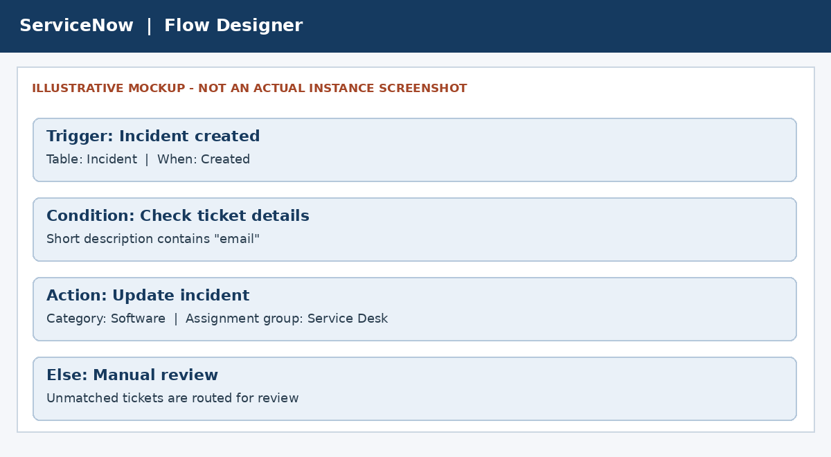
Illustrative mockup only. Replace with a screenshot from your own ServiceNow Flow Designer.

2. Classification Output
The following example shows the expected incident details after a classification rule matches.
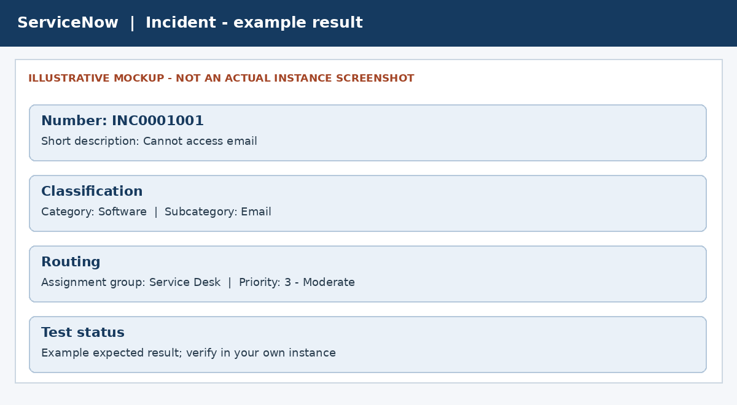
Illustrative mockup only. Replace with an actual incident record screenshot.

3. Accuracy
Rule-based workflow: training accuracy and validation accuracy do not apply unless an ML model is included.
Testing accuracy = (Correctly classified tickets / Total test tickets) x 100
Total tested: ______ Correct: ______ Testing accuracy: ______%

4. Confidence Score
Not applicable: this is a Flow Designer rule-based project, not a YOLO model.

